- DiamondMind 3D Printer

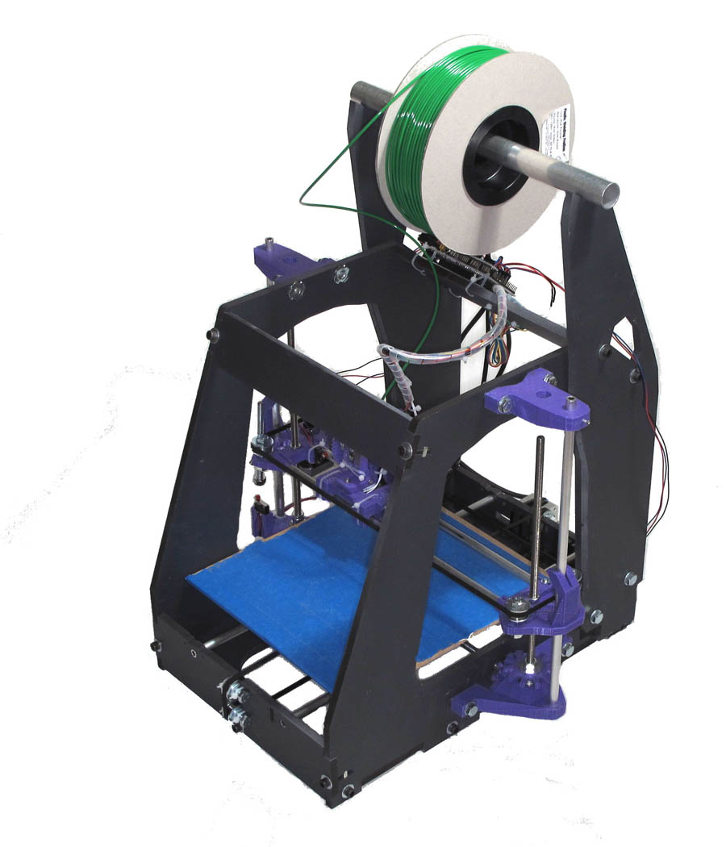

Documentation – Electronics build and setup

Electronics build

- If the Arduino mega board and the ramps board are separate, join them by mating the Ramps board on top of the Arduino board, carefully aligning the pins on one into the sockets on the other.

- Attach the Mega and ramps board bundle to the right end cheese board (top rear) with three small cable ties, in appropriate holes - see picture.

- 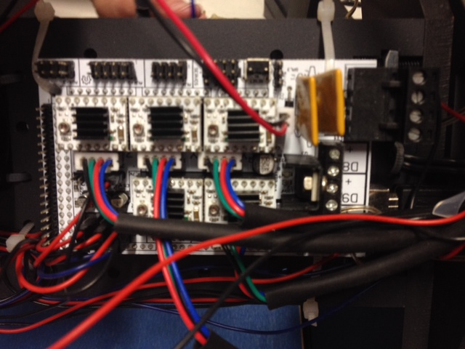

- Two back wires are for the heater in the hotend – these plug in to the ramps board D10, and the polarity is not important. What is important is that wires are seated well in the screw terminals so no copper is visible (so the risk of short circuits are minimised).

Take all your stepper motor wiring cables and check they have the same wire colour arrangement – Black, green, red, blue. If they’re not all the same, don’t use the cable until it’s replaced or fixed.

- The plug with four coloured wires goes to the stepper – plug this onto the ramps board E0 (extruder zero), so that (looking from the rear) the black wire is far left (notches in the plug face inwards to the board). They should go black (far left), green, red and blue (far right).

- In the wire parts bag there are 3 sets of red/black wires
- a) a set for the hotend fan.
- b) a set for the thermistor with a plug on the end (labelled therm on the plug)
- c) a set for the stepper motor fan

- Fit the thermistor plug to ramps board T0.

Fans and Power
- Take the cigarette adaptor and cable – strip the wires. Note that the one with a raised stripe or white stripe is the positive side. Also strip the two sets of fan wires (hotend stepper and heater fans).

- Tightly wind the three positive wires together, and then the negative wires together.
- Attach these power wires into the 5A power on the ramps board. (Note that there are 4 terminals – 2 are labelled 11A and 2 are labelled 5A). Make sure that all positives are connected and go to the +ve terminal; all negatives are connected and go to the -ve terminal.
- Feed the cigarette adaptor piece through the hole in the frame.
- 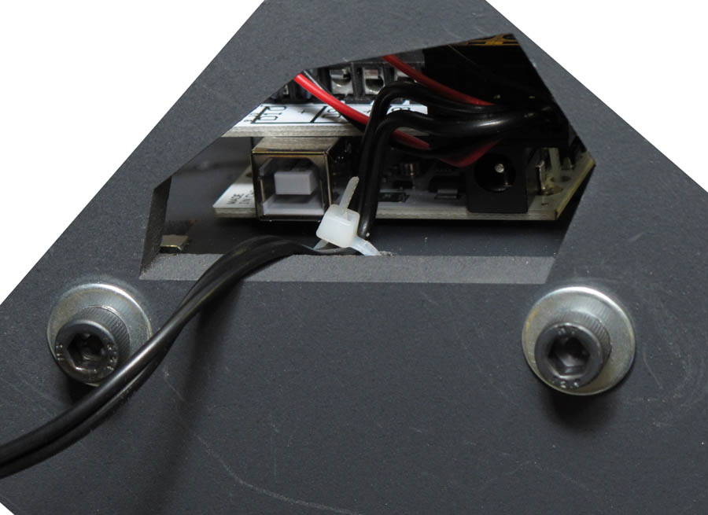
Illustration 1: Power cable comes out from Ramps board through hole in frame. Note that this picture is rotated 180 degrees to show board. Also note top of cable tie securing wires to frame.

- Cable tie these wires down onto the frame so they can't be pulled out.

Set up the extruder stepper jumpers.
- Under the stepper driver boards on the ramps board are 3 sets of jumpers. We need to remove two of these to enable microstepping.

Note:We only do this to the Z driver and the Extruder0 drivers.

- Extruder0: Touch a grounded metal object to remove static charge. Remove the driver board and remove left and right jumpers, leaving only the middle jumper attached.
- Replace board, being careful not to bend the pins, crush the driver chip or fry the board with electrostatic discharge.

- Z Stepper Driver: As per the extruder – Remove the board labelled Z and remove left and right jumpers.
- Replace the stepper driver board.

Adding Heatsinks to The Stepper Driver Boards
- Heatsinks and sticky pads are in a kit bags.
- Remove heatsinks. Place sticky pad set on the bench. Remove protective paper. Take one heatsink and place it on a sticky pad to attach it to the heatsink. Lift so the pad is on the heatsink. Now attach the heatsink carefully to the black chip on the stepper driver board.
- Repeat for all drivers.
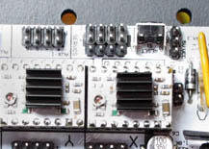

Endstops
- Attach wires to X Y Z end stop switches
- These microswitches connect to the Ramps board with 3 wire cables. The cables need to be cut to length and cable tied into place.
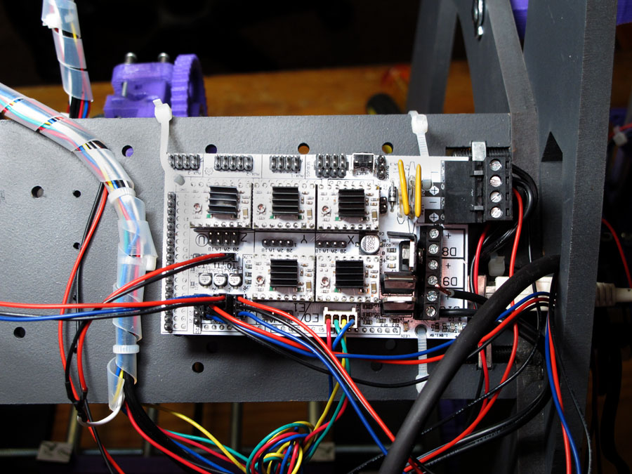
Illustration 2: Heatsinks applied to two of the motor driver chips
- Note that the stepper wires in this picture are incorrect for current gen steppers. Don’t use this picture as a guide for stepper wiring. Use it for endstops only.

- Start with the Z axis end stop that sits on the Z motor side bracket.
- Use the wire that has “end stop” printed on the plug.
- To get the correct wire length, put the switch in the cavity on the bracket. Attach the wire plug to the board in the area on the board labelled 'S' and run the wires down the outside of the frame and to the switch, which gives you the length of the wires. Allow a little slack on the wires, then cut and solder the wires to the switch.

- Wires on all switches connect as follows:
- a) Red wire to NC (normally closed)
- b) Black wire to NO (normally open)
- c) Blue wire to Common

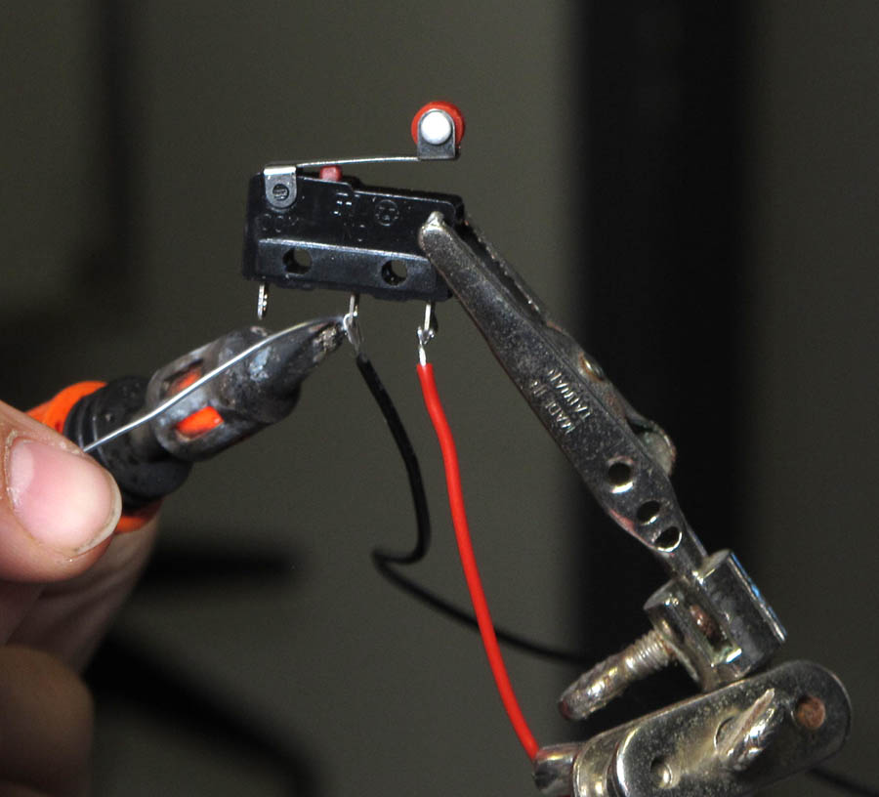
- Note: Rely on the wiring information above not the picture. Your switches may not have pins in the same order. You can see the abreviations written on the switch case.

- Position the switch in the bracket cavity.
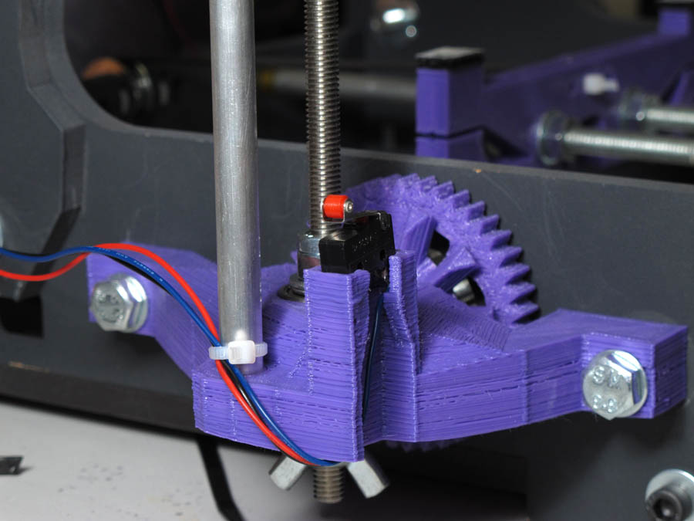
Illustration 3: Z axis end stop microswitch in position
- Cable tie the wire to the bottom of the Z runner.

- Now the Y axis switch. This sits in a cavity on the rear lower frame. Once the wires are connected to the switch, place it in the cavity with the red wheel upwards. It now cables ties to the frame, pushing the cable tie through the small hole in the switch (it may require pliers to pull it right through).
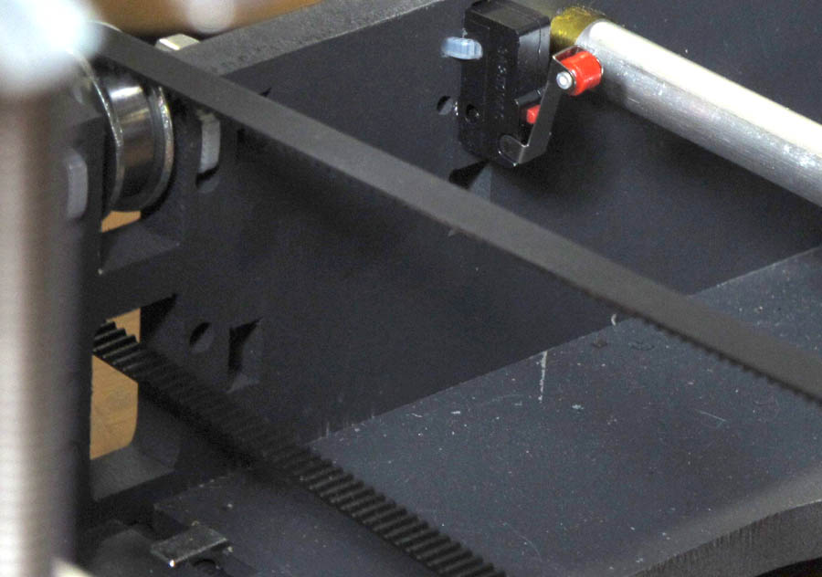
Illustration 4: Y axis end stop microswitch in position. Note cable tie through hole in switch and frame

- Finally, the X axis end stop. This fits in a cavity on the X axis motor bracket. Position the switch and leave enough cable so that the Z axis is free to move up and down. A cable tie goes around the whole switch, bracket and X axis rod.

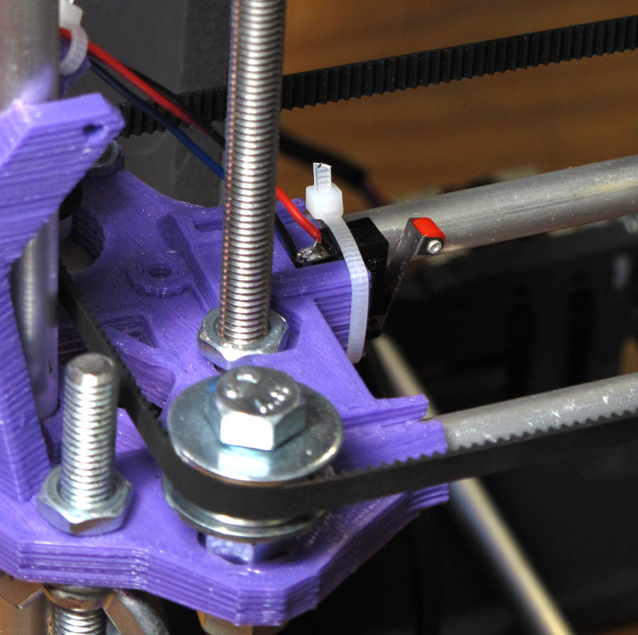
Illustration 5: X axis end stop microswitch in position. Note cable tie around switch, runner and bracket

- Connect the plugs to the 'S' area, which is also labelled 'end stops'. X, Y, Z end stops connect to pins 1, 3, 5 respectively (numbering from the inner of the board to the outer edge). They are also labelled XYZ on the board if you don’t feel like getting overly numerical with the pins.

Connecting The Motors
- Use the supplied four wire motor leads. On the motors these are keyed so they fit only one way round. Attach the leads to the motors. The X axis motor lead comes outside the frame and through the hole in the frame beside the electronics boards.
- On the ramps board the pins are marked for each of the X, Y Z motors. Connect them to the correct axis connection. These are not keyed but if they are the wrong way round, the motor will run in reverse! Watch for this now you know the cause.

The electronics are finished.
You might decide to go back over these instructions again to ensure you have everything right. Remember – putting the magic smoke back in is a lot harder than letting it out so it’s worth the extra time to check for mistakes.

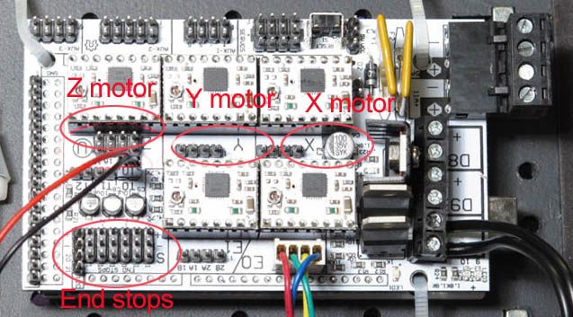
Illustration 6: End stop area and motor connections
Once again, note that the stepper motor cable shown has different colouring than the one you have in your kit. The cake is a lie.

